AWS ACADEMY MODULES NOTES

MODULE-1

INTRO TO AWS

Topics

* Intro to cloud computing
* Adv of cloud computing
* Intro to aws
* Aws cloud adoption framework

1. **Intro to cloud computing**

Cloud Computing?

Cloud Computing is the on demand delivery of compute power database storage applications and other IT services through a cloud services platform via the internet with pay as you go pricing.

Advantages:

* Cost-Effective
* Scalability
* Accessibility
* Flexibility and Speed
* Backup and Recovery
* Security

Disadvantages:

* Dependence on Internet Connectivity
* Limited Control
* Potential Downtime
* Cost Overruns
* Data Security and Privacy Concerns
* Moving data to other cloud platform

Types of cloud based on Deployment Models

**Public Cloud**

* **Definition**: Services are provided over the internet and shared among multiple organizations.
* **Hosted By**: Third-party cloud providers (e.g., AWS, Microsoft Azure, Google Cloud).
* **Example Use Case**: Hosting websites, SaaS applications.
* **Advantages**: Cost-effective, scalable, no maintenance required by the user.
* **Disadvantages**: Less control over data and security concerns for sensitive information.

**Private Cloud(On-premises)**

* **Definition**: Services are used exclusively by a single organization and hosted either on-premises or by a third-party provider.
* **Hosted By**: The organization or a dedicated vendor.
* **Example Use Case**: Banking or government systems that require high security.
* **Advantages**: More control, enhanced security, and customization options.
* **Disadvantages**: Higher costs for setup and maintenance.

**Hybrid Cloud**

* **Definition**: A mix of public and private clouds, enabling data and applications to be shared between them.
* **Hosted By**: A combination of private infrastructure and third-party providers.
* **Example Use Case**: Businesses with sensitive data (stored privately) and less-critical workloads (on the public cloud).
* **Advantages**: Flexibility, scalability, and cost-effectiveness for non-sensitive workloads.
* **Disadvantages**: Can be complex to manage and integrate.

Types of cloud based on service models

**a. Infrastructure as a Service (IaaS)**

* **Definition**: Provides virtualized computing resources like servers, storage, and networking.
* **Example Providers**: AWS EC2, Google Compute Engine, Microsoft Azure.
* **Example Use Case**: Hosting websites, application development environments.
* **Advantages**: Complete control over the infrastructure.
* **Disadvantages**: Requires technical expertise for management.

**b. Platform as a Service (PaaS)**

* **Definition**: Provides a platform with tools and frameworks for developers to build, test, and deploy applications.
* **Example Providers**: Google App Engine, AWS Elastic Beanstalk, Heroku.
* **Example Use Case**: Developing web or mobile apps.
* **Advantages**: Simplifies development, no need to manage the underlying infrastructure.
* **Disadvantages**: Less control over the environment.

**c. Software as a Service (SaaS)**

* **Definition**: Provides ready-to-use software applications over the internet.
* **Example Providers**: Google Workspace, Microsoft 365, Salesforce.
* **Example Use Case**: Email services, CRM tools, collaboration software.
* **Advantages**: Easy to use, no maintenance required.
* **Disadvantages**: Limited customization and dependence on the provider for updates.

1. Advantages of Cloud Computing

Six advantages

* 1. Pay only for the amount you consume
  2. Economics of Scale(Savings)
  3. Stop guessing capacity
  4. Increase speed and agility
  5. Stop spending money on data centers and maintaince
  6. Go global in minutes

1. Intro to AWS

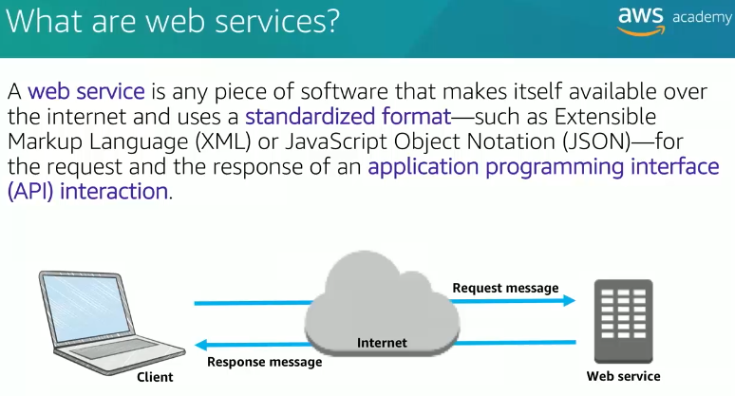

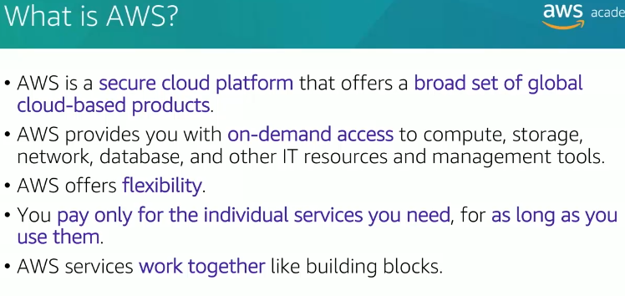

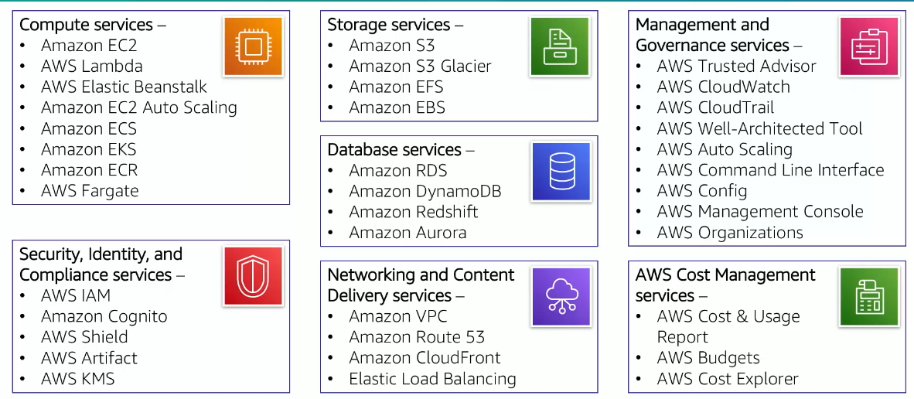

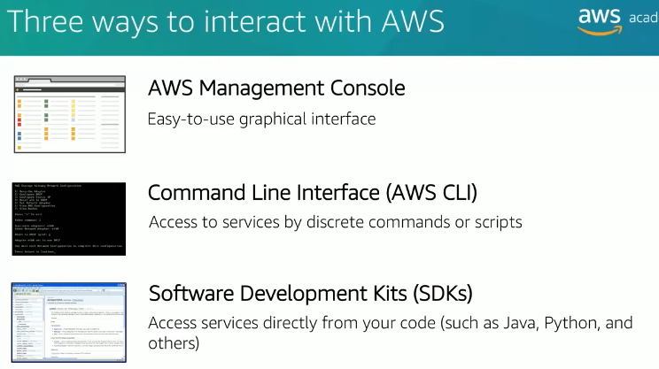

1. **Moving to Amazon Cloud using Cloud Adoption Framework(CAF)**

The **Amazon Cloud Adoption Framework (CAF)** is a structured framework designed by AWS to help organizations plan and implement their cloud adoption journey effectively. It provides guidance, best practices, and a set of perspectives to align business and technical strategies for successful cloud transformation.

**Key Objectives of Amazon CAF**

1. **Accelerate Cloud Adoption**:
   * Helps organizations move to the cloud faster while mitigating risks.
2. **Identify Gaps**:
   * Ensures alignment between business goals and technical capabilities.
3. **Create a Holistic Plan**:
   * Provides a framework for aligning people, processes, and technology.
4. **Drive Change Management**:
   * Facilitates cultural and operational changes for cloud adoption.

**Perspectives of Amazon CAF**

The Amazon CAF consists of **six key perspectives** categorized into **business** and **technical domains**. These perspectives help stakeholders address specific responsibilities and challenges during cloud adoption.

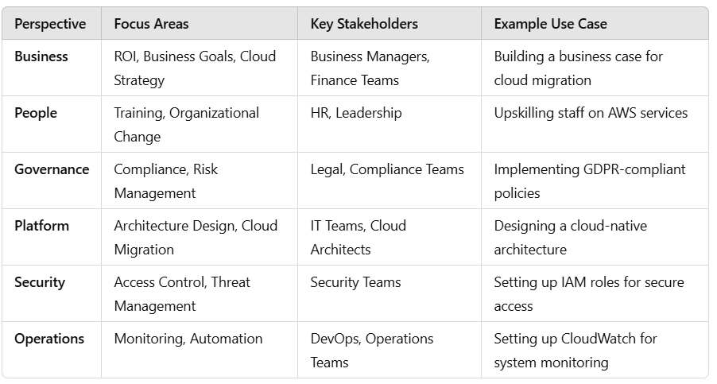

**Real-World Example**

**Scenario:**

A retail company wants to migrate its on-premises ERP system to AWS.

* **Business Perspective**: Define the business case and expected ROI from moving to AWS.
* **People Perspective**: Train IT staff on AWS services like RDS, EC2, and S3.
* **Governance Perspective**: Establish financial controls to monitor AWS costs.
* **Platform Perspective**: Design a cloud architecture to run the ERP system efficiently.
* **Security Perspective**: Implement encryption for sensitive customer data using AWS KMS.
* **Operations Perspective**: Use AWS CloudWatch to monitor system performance and logs.

MODULE-2

BILLING & MANAGEMENT

Topics

. Fundamentals of pricing

. Total Cost of Ownership

. AWS Organizations

. AWS Billing and Cost Management

. Technical Support

1. **Fundamentals of pricing**

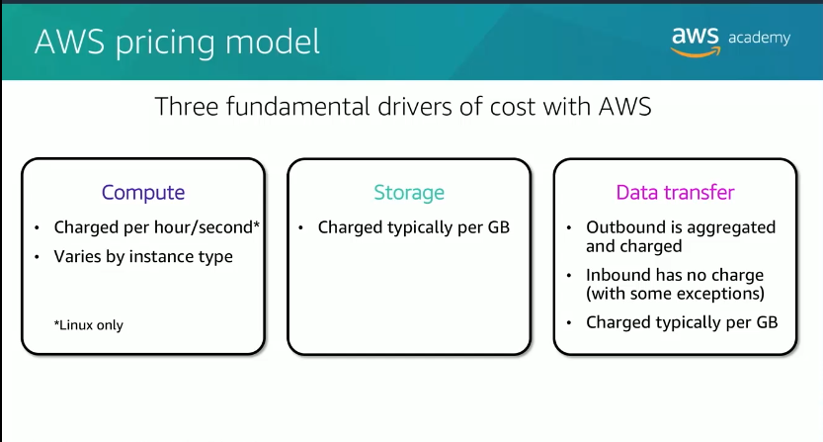

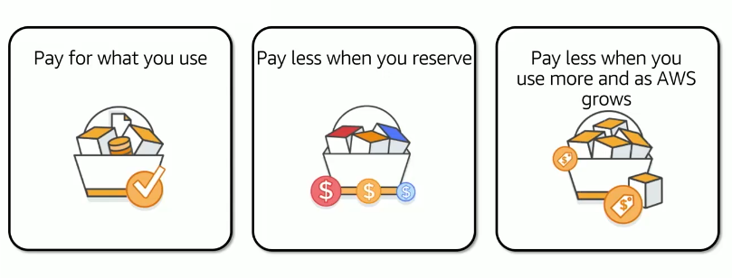

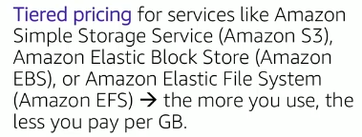

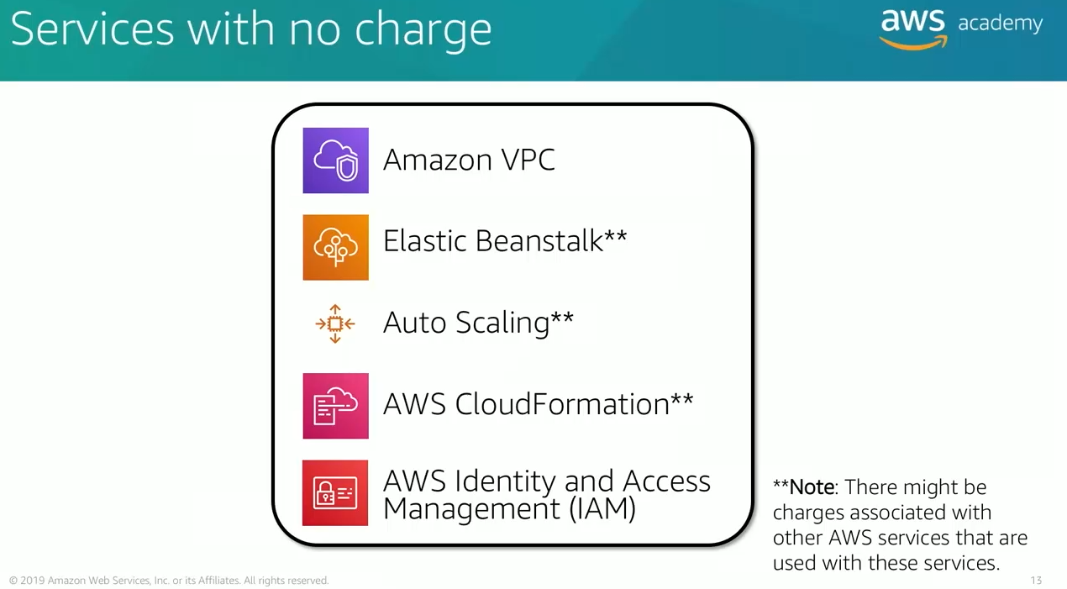

1. **Total Cost of Ownership**

**TCO** stands for **Total Cost of Ownership**. It is a financial metric used to estimate the overall cost savings and benefits of running workloads on AWS compared to an on-premises data center or other cloud providers.

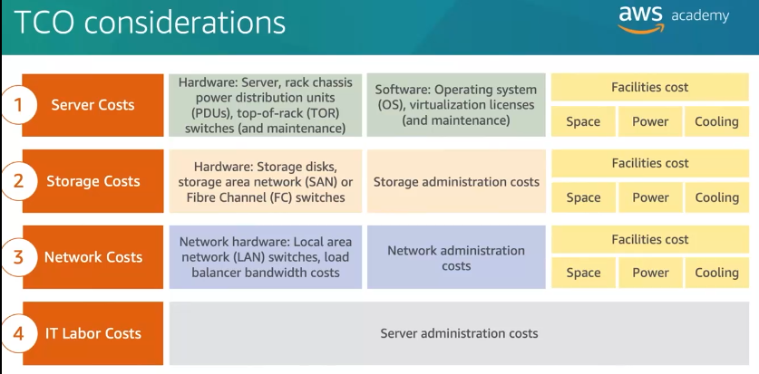

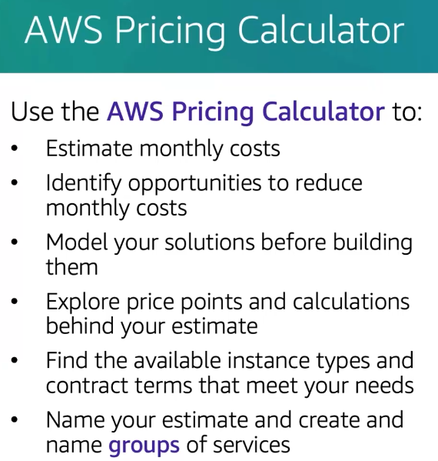

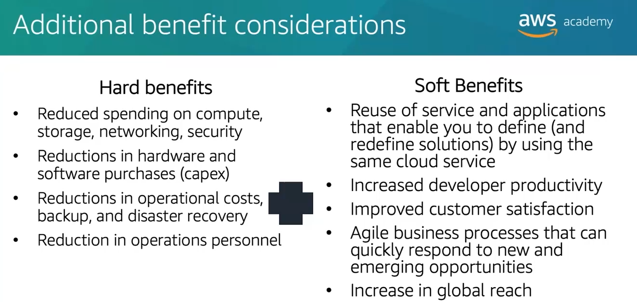

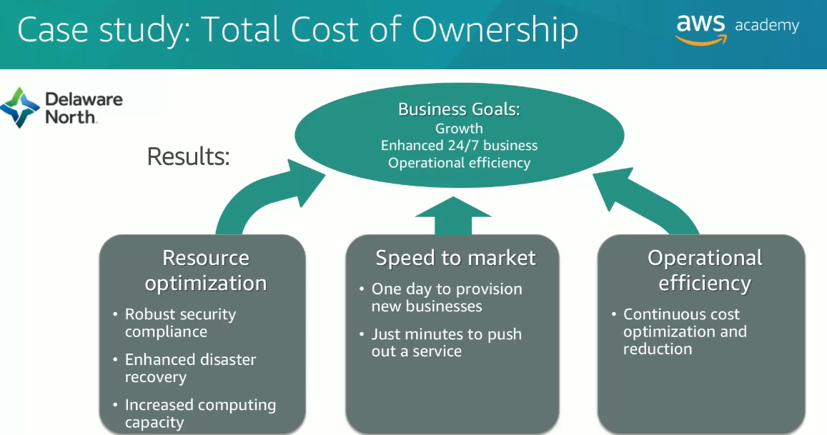

1. **AWS Organizations**

AWS Organizations is a service that helps you centrally manage and govern multiple AWS accounts. It allows you to consolidate billing, set policies, and manage permissions across all accounts within your organization. It's especially useful for organizations that have multiple accounts for different departments, projects, or teams and want to streamline their AWS management.

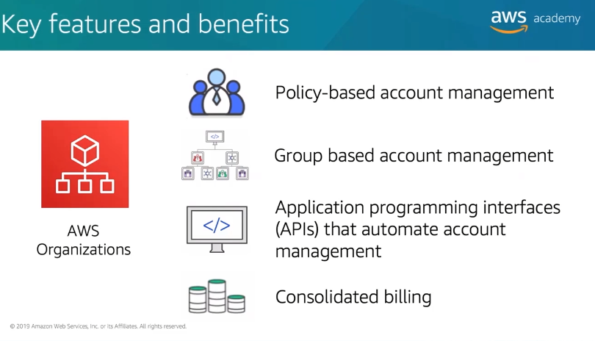

**Benefits:**

1. **Cost Savings:**
   * Optimize costs with consolidated billing and resource sharing.
2. **Improved Governance:**
   * Enforce security and compliance standards uniformly across accounts.
3. **Simplified Administration:**
   * Centralized account management reduces administrative overhead.
4. **Scalability:**
   * Easily add or remove accounts as your organization grows.

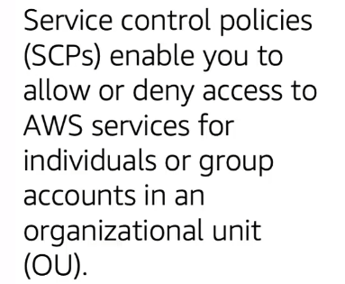

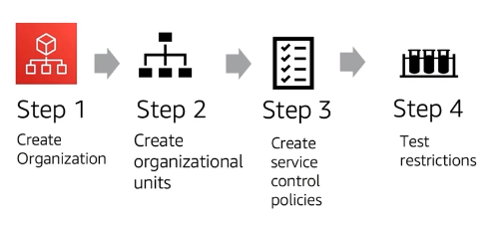

1. **AWS BILLING**

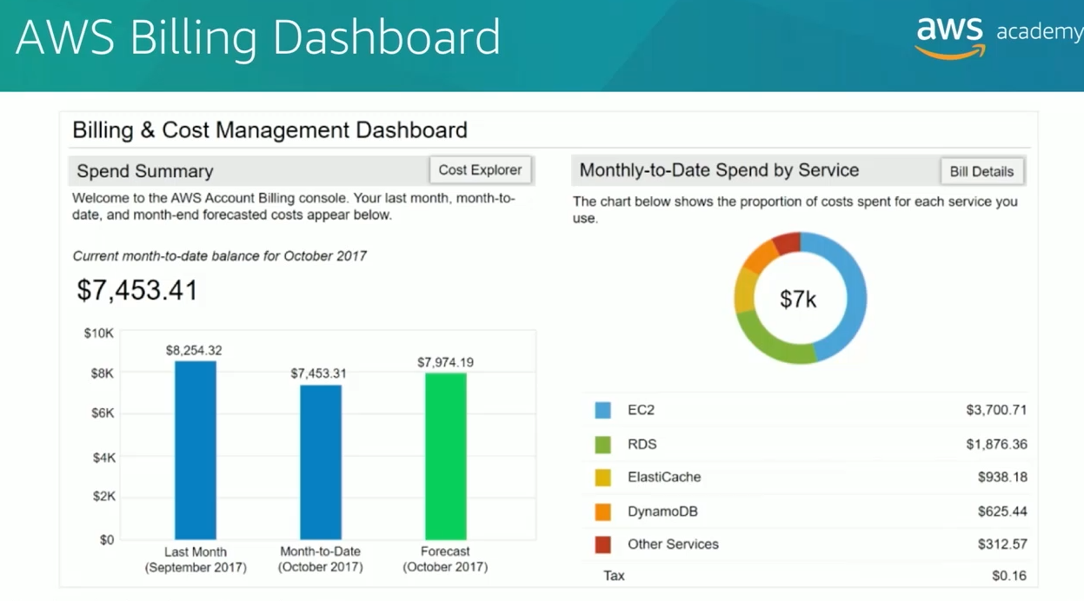

Tools:

1. AWS Budgets
2. AWS Cost and Usage Report
3. AWS Cost Explorer

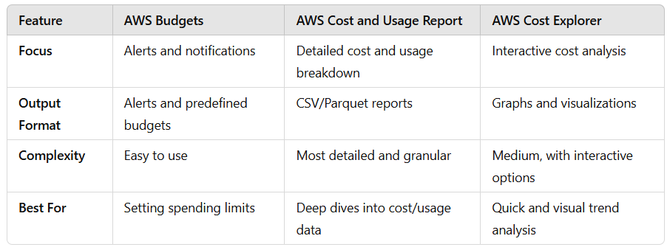

1. **Technical Support Models or AWS Support**

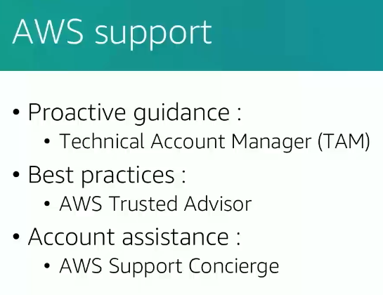

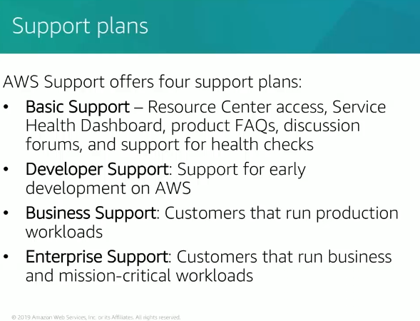

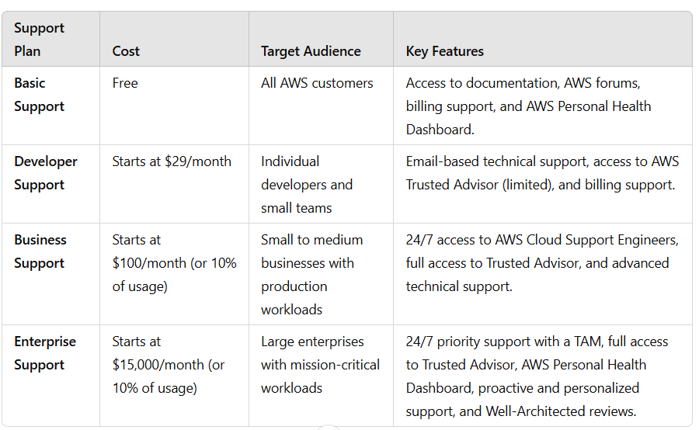

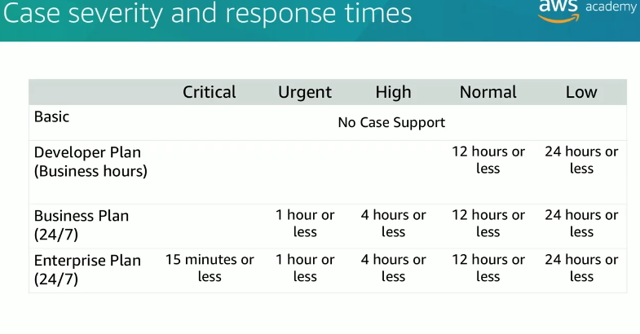

MODULE-3

AWS GLOBAL INFRASTRUCTURE

Topics:

1. AWS Global Infrastructure
2. AWS Service and service category overview

1.AWS Global Infrastructure

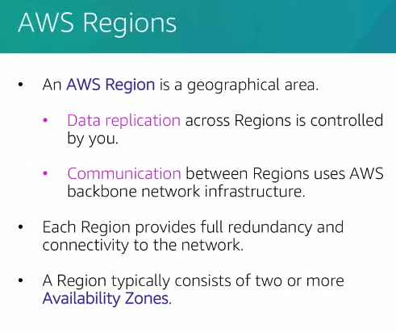

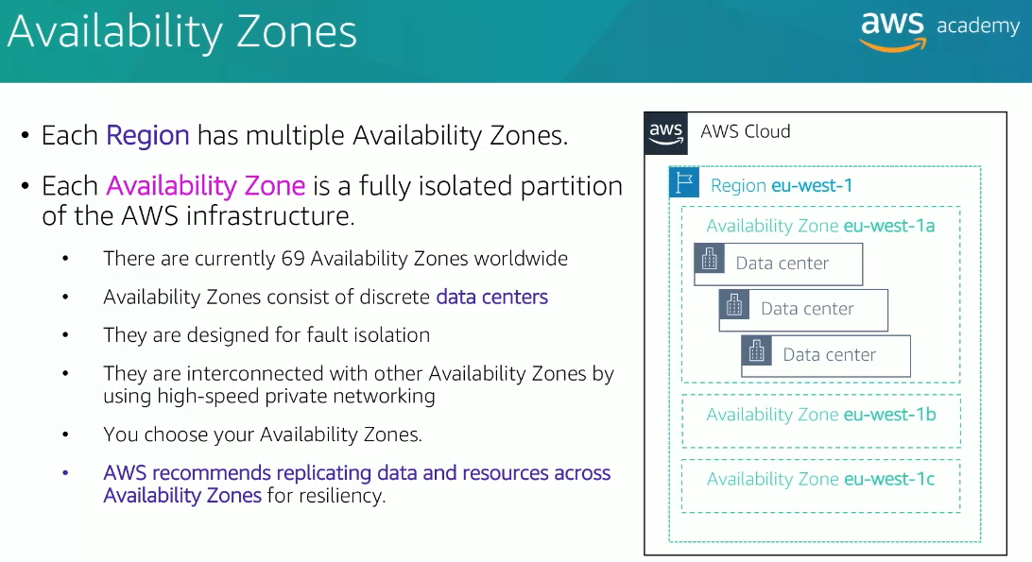

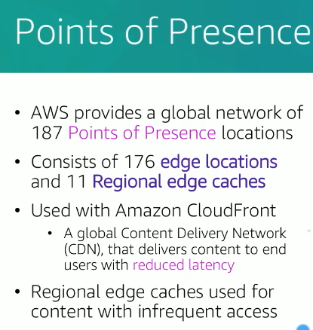

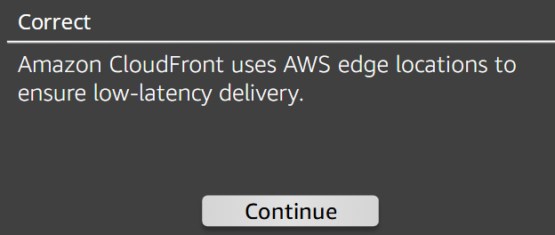

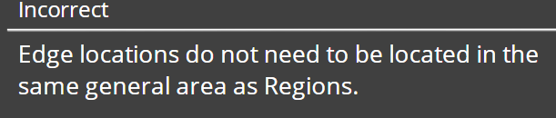

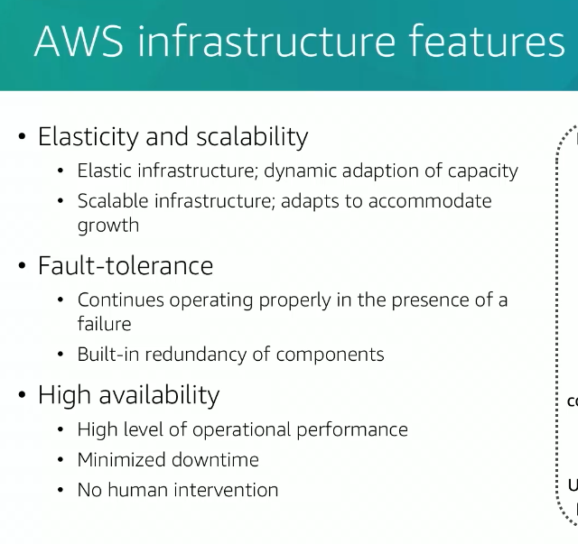

2.AWS Services and categories

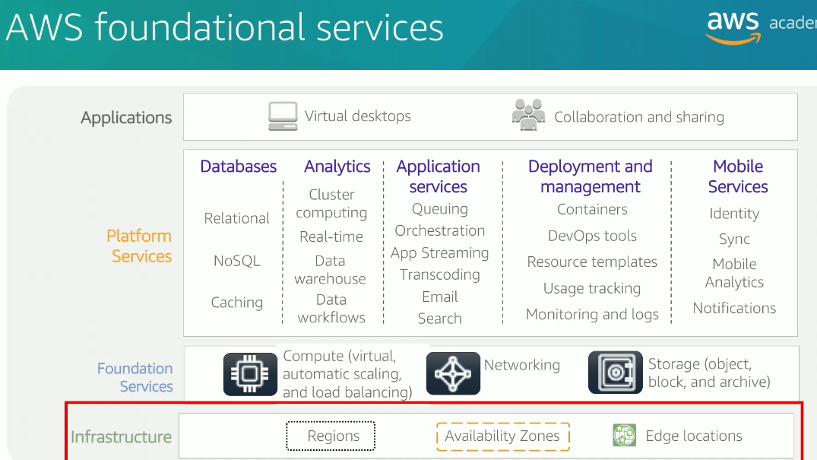

i)AWS Storage services

1)S3

2)EBS

3)EFS

4)S3 Glacier

ii)AWS Compute Services

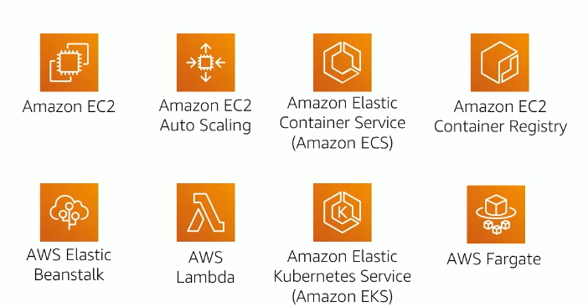

iii)AWS Database Services

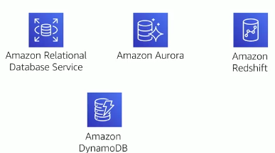

iv)AWS Networking and Content Delivery Services

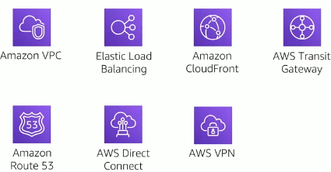

v)AWS Security,identity and compliance services

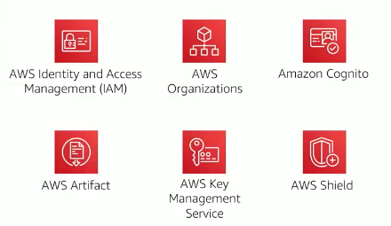

vi)AWS Cost and Management Services

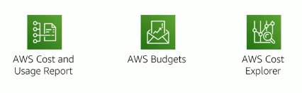

vii)AWS Management and Governance Services

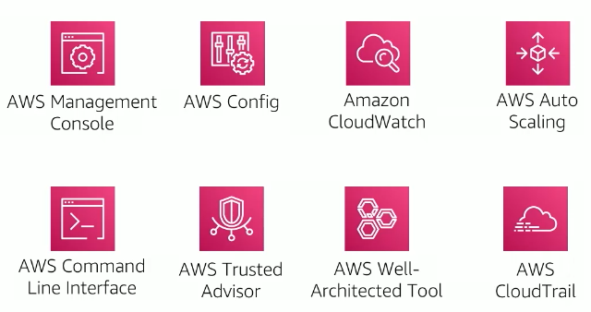

Module 4

AWS CLOUD SECURITY

Topics

. AWS shared responsibility model

. AWS Identity and Access Management (IAM)

. Securing a new AWS account

· Securing accounts

. Securing data on AWS

· Working to ensure compliance

1.AWS Shared Responsibility model

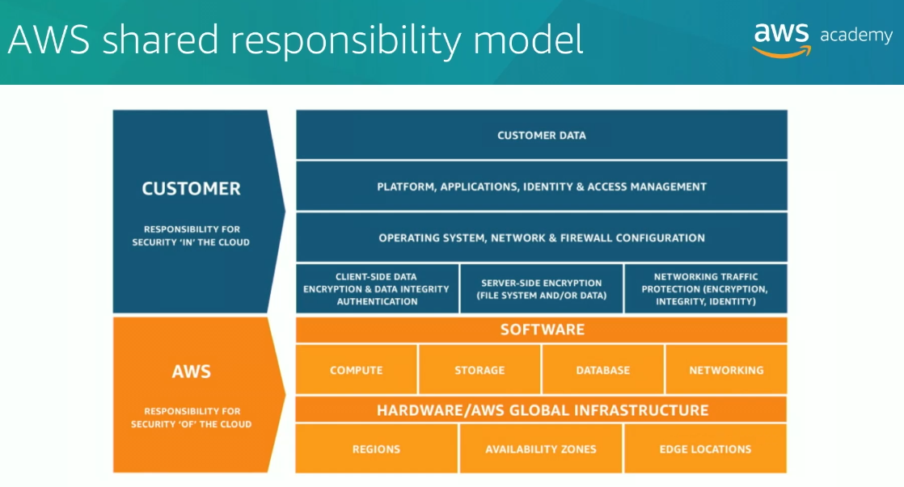

**AWS responsibilities:**

Physical security of data centers

Controlled, need-based access

· Hardware and software infrastructure

Storage decommissioning, host operating system (OS) access logging, and auditing

· Network infrastructure

Intrusion detection

· Virtualization infrastructure

instance isolation

**Customer responsibilities:**

· Amazon Elastic Compute Cloud (AmazonEC2) instance operating system

. Including patching, maintenance

· Applications

. Passwords, role-based access, etc.

. Security group configuration

. OS or host-based firewalls

. Including intrusion detection or prevention systems

· Network configurations

· Account management

. Login and permission settings for each user

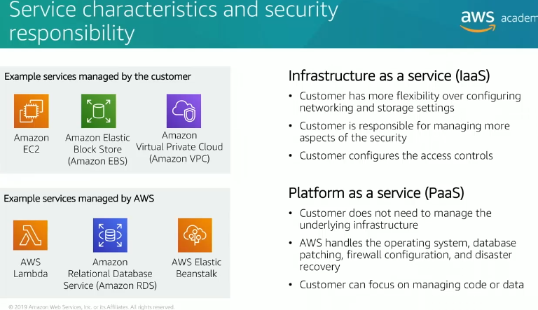

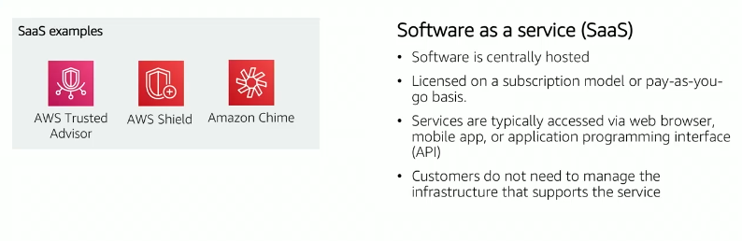

2.IAM

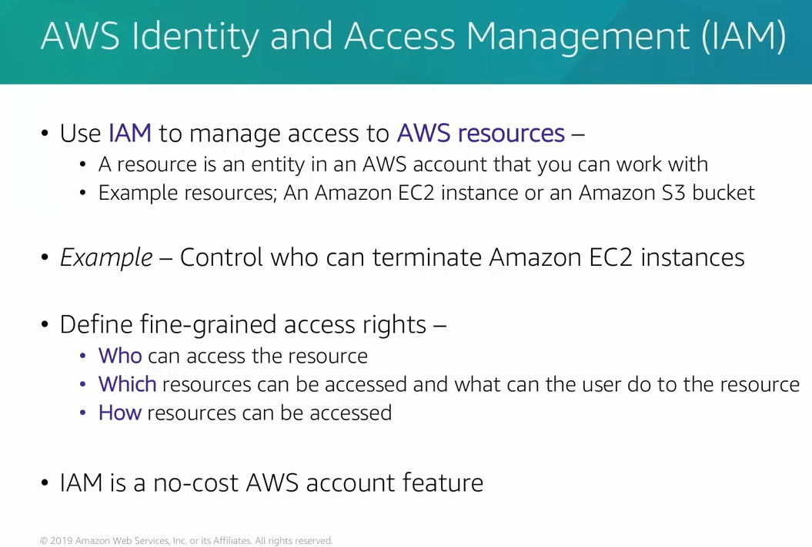

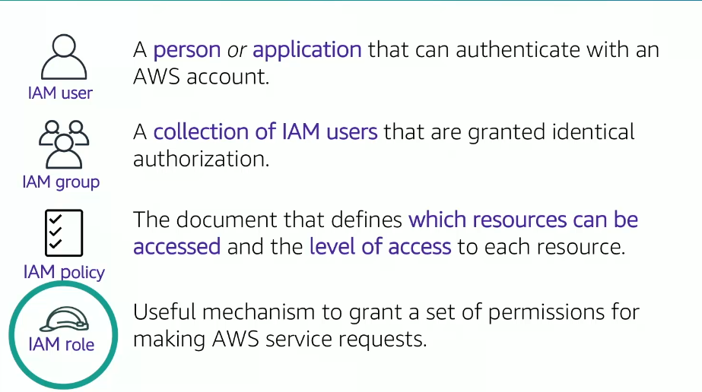

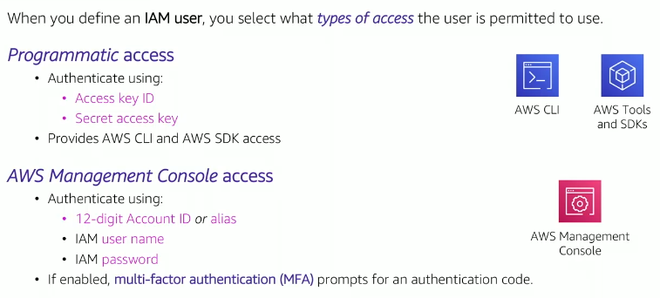

**MFA:**

**AWS IAM MFA (Multi-Factor Authentication)**

**Definition:**  
AWS IAM (Identity and Access Management) MFA adds an extra layer of security by requiring users to provide two forms of authentication to access their AWS account:

1. **Something they know** (password or access key).
2. **Something they have** (a physical or virtual MFA device).

**Key Features of IAM MFA**

1. **Increased Security:**
   * Protects against unauthorized access, even if credentials are compromised.
2. **Supported MFA Devices:**
   * **Virtual MFA devices:** Smartphone apps like AWS Virtual MFA, Google Authenticator, or Authy.
   * **Hardware MFA devices:** Physical tokens like YubiKey.
   * **U2F Security Keys:** USB-based authentication devices.
   * **SMS MFA:** Sends a code to the user's phone (not supported for root users).
3. **Usage:**
   * Can be enabled for **IAM users**, the **AWS root account**, or individual roles.

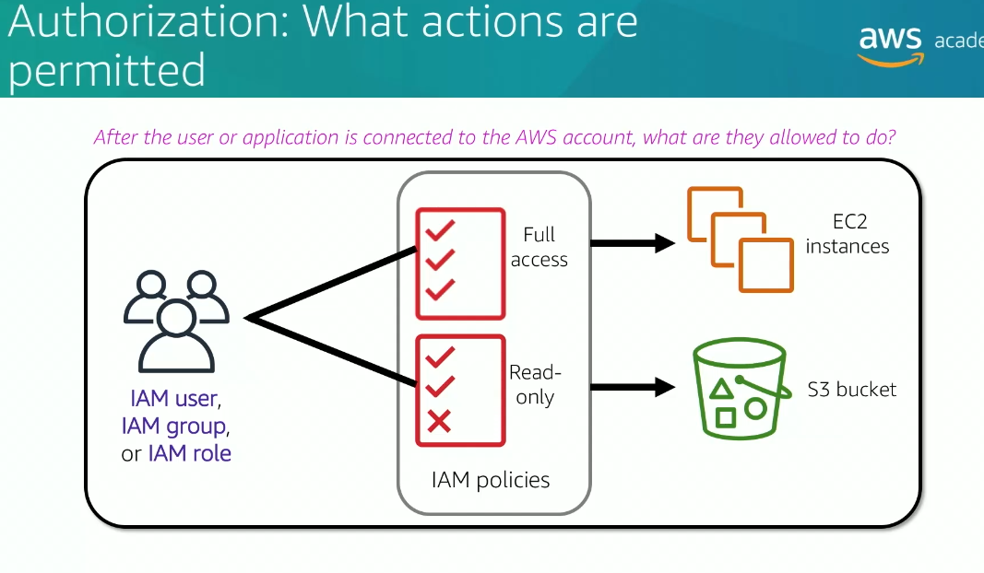

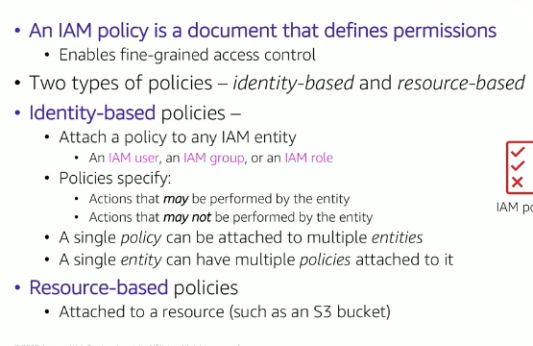

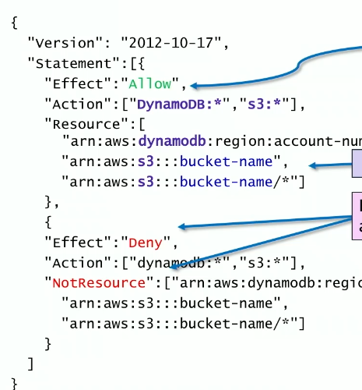

Example of JSON File In policy

Note: Deny effect will overwrite the allow effect in policy

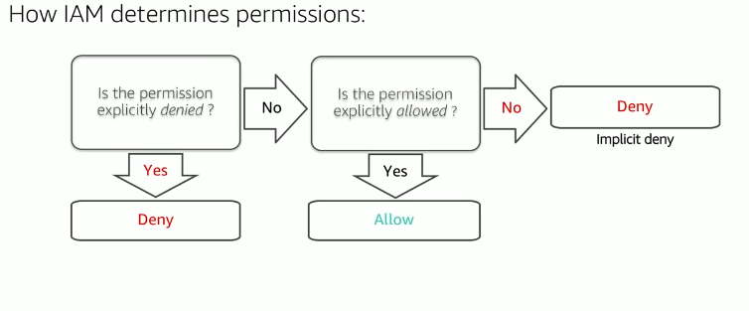

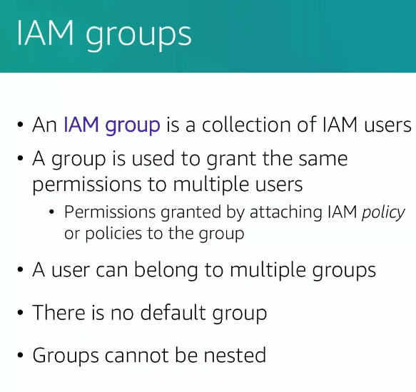

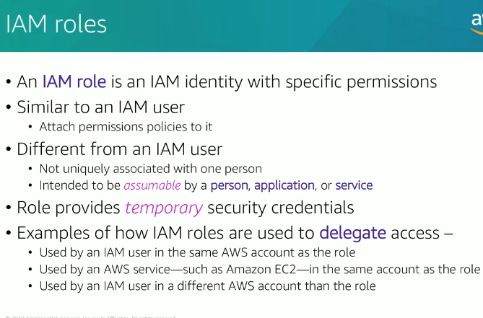

1. Securing a new AWS account

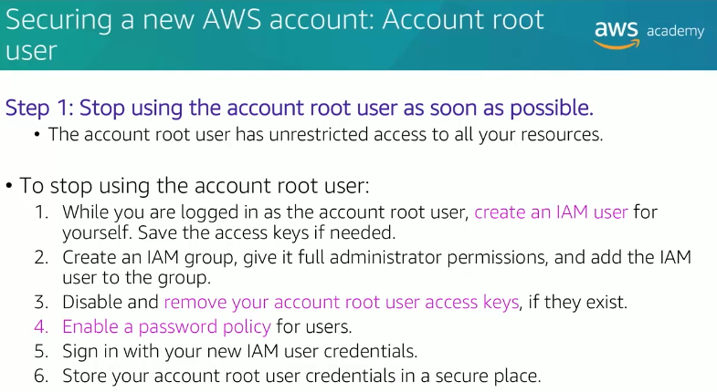

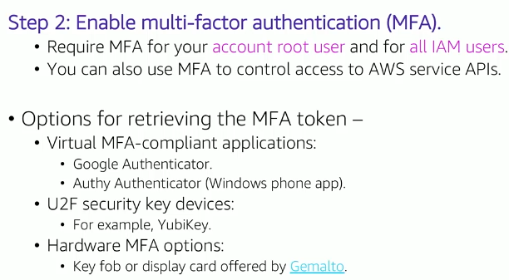

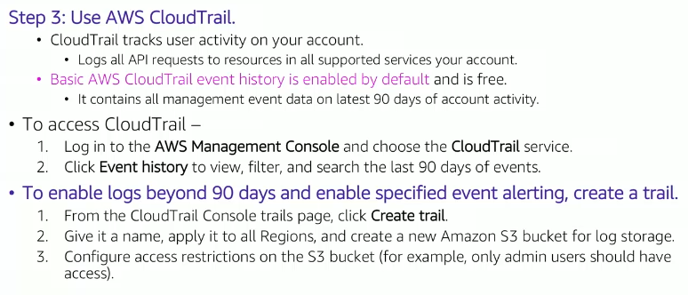

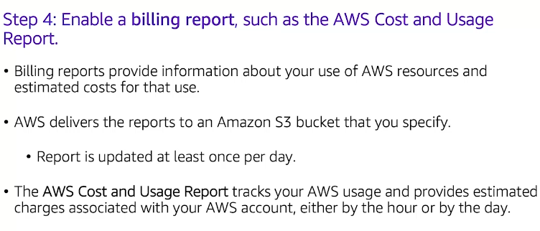

4.Securing AWS accounts

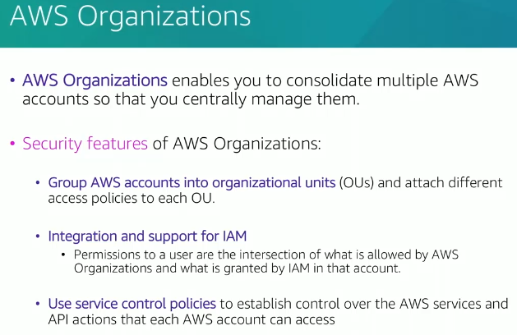

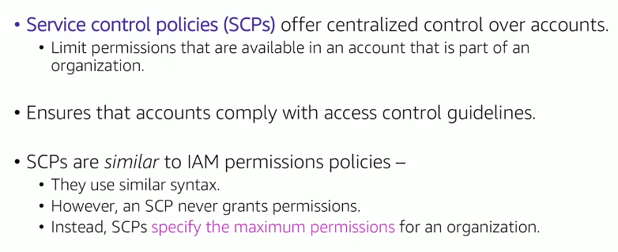

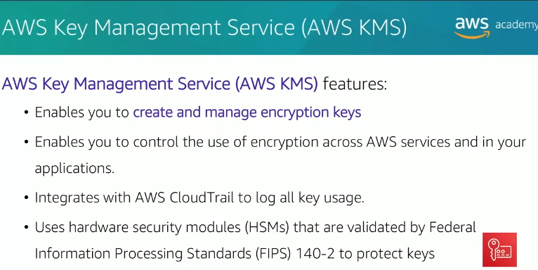

**What is AWS KMS (Key Management Service)?**

AWS Key Management Service (KMS) is a fully managed service that allows you to create, manage, and control cryptographic keys used to encrypt and decrypt data. It provides a secure and scalable way to handle encryption keys for AWS services and your own applications.

**Key Features of AWS KMS**

1. **Centralized Key Management**
   * Manage keys for multiple AWS services like S3, EBS, RDS, and DynamoDB.
   * Create, rotate, and delete encryption keys.
2. **Secure and Scalable**
   * The keys are stored in FIPS 140-2 compliant hardware security modules (HSMs).
   * Scales automatically to handle high-volume requests.
3. **Integration with AWS Services**
   * Works seamlessly with services like S3, RDS, Lambda, EBS, etc.
4. **Granular Access Control**
   * Use IAM policies to define who can use and manage your keys.
5. **Automatic Key Rotation**
   * Rotates keys automatically every 1 year (optional) to improve security.
6. **Audit and Compliance**
   * Integrated with AWS CloudTrail to log all key usage and management activities.

**Types of Keys in AWS KMS**

1. **Customer Managed Keys (CMKs)**
   * Created, managed, and used by you.
   * Offers more control (e.g., key rotation, access policies).
2. **AWS Managed Keys**
   * Created and managed by AWS for its services.
   * Easier to use but with limited control.
3. **AWS Owned Keys**
   * Fully managed by AWS, used internally for AWS services.
   * Not visible or accessible to customers.
4. **Data Keys**
   * Used for local encryption and decryption operations (not stored in KMS).

**How AWS KMS Works**

AWS KMS uses a concept called **Envelope Encryption**:

1. Data is encrypted using a **Data Encryption Key (DEK)**.
2. The DEK itself is encrypted using a **Master Key (CMK)** in AWS KMS.
3. This two-layer encryption ensures that the data and its encryption key are secured.

**Example Use Case**

**Scenario: Encrypting an S3 Object with AWS KMS**

1. **Step 1: Create a Customer Managed Key (CMK)**
   * Go to the AWS Management Console → KMS → Create Key.
   * Choose the key type (symmetric or asymmetric).
   * Configure key policies to control who can access or manage the key.
2. **Step 2: Use the Key to Encrypt Data in S3**
   * Enable default encryption for your S3 bucket:
     1. Navigate to the S3 bucket in the AWS Management Console.
     2. Go to **Properties → Default Encryption**.
     3. Select **AWS-KMS** and choose your CMK.
3. **Step 3: Upload an Object**
   * When you upload an object to the bucket, AWS will:
     1. Generate a unique Data Encryption Key (DEK).
     2. Encrypt the object with the DEK.
     3. Encrypt the DEK with your KMS key (CMK).
   * Only users with access to the CMK can decrypt the object.
4. **Step 4: Access Logs and Key Usage**
   * Use AWS CloudTrail to track all KMS API calls, such as encryption and decryption events.

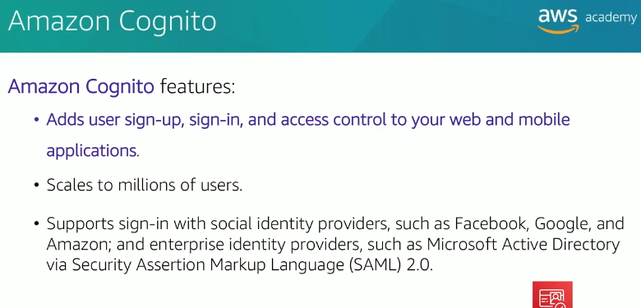

**What is AWS Cognito?**

AWS Cognito is a managed service provided by AWS for **user authentication, authorization, and user management** in web and mobile applications. It simplifies the process of adding sign-up, sign-in, and access control capabilities, while also enabling integration with social identity providers (like Google, Facebook) or enterprise identity systems via SAML 2.0 and OpenID Connect.

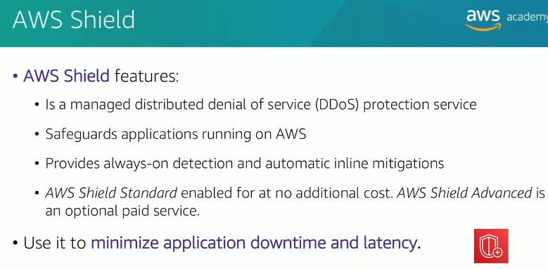

**What is AWS Shield?**

AWS Shield is a managed Distributed Denial of Service (**DDoS**) protection service offered by AWS to safeguard your applications running on AWS infrastructure. It provides automatic detection and mitigation of DDoS attacks, helping maintain the availability and performance of your applications.

**Types of AWS Shield**

AWS Shield comes in two tiers:

1. **AWS Shield Standard**:
   * Automatically available at no extra cost for all AWS customers.
   * Provides basic protection against common and most frequently occurring DDoS attacks (e.g., SYN/ACK floods, UDP reflection attacks).
2. **AWS Shield Advanced**:
   * A premium service with enhanced DDoS protection.
   * Includes detailed attack diagnostics, cost protection during DDoS attacks, and access to the AWS DDoS Response Team (**DRT**) for 24/7 support.

5.Securing Data

Data at rest – Physically stored data

Data at Transit – Data moving across the network

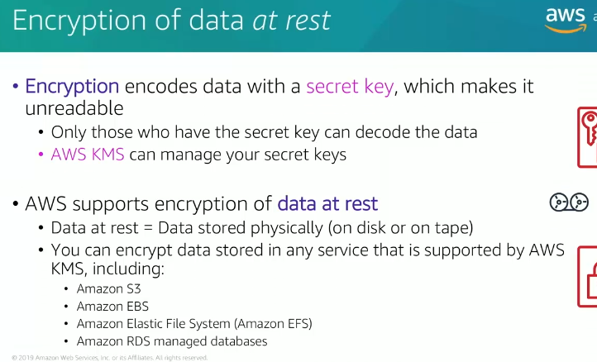

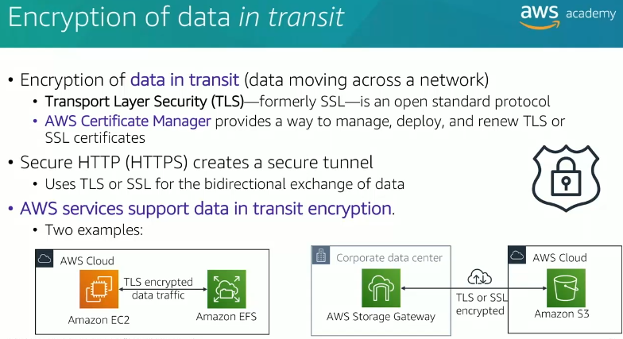

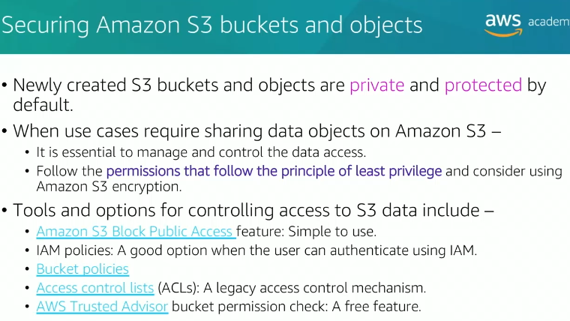

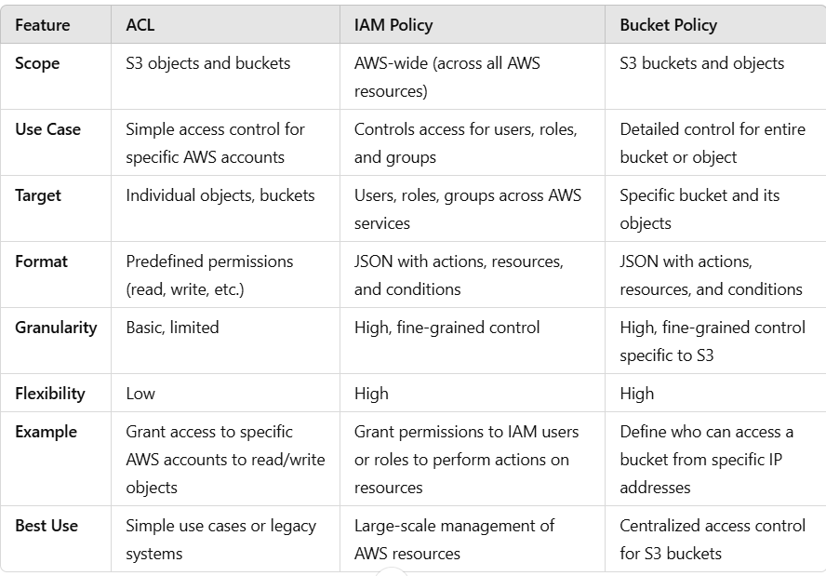

6.Working to Ensure Compliance

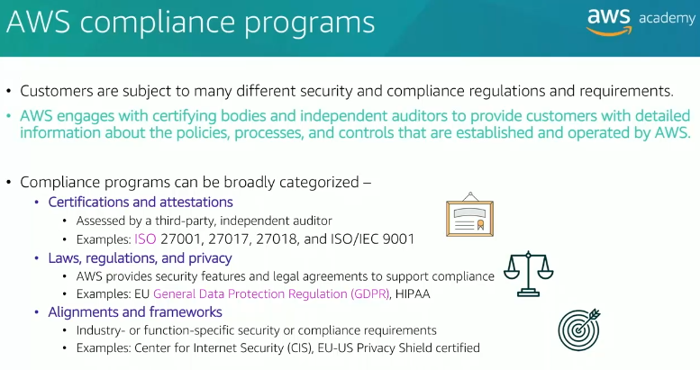

In the same way, **AWS Compliance Program** is like the **rules** and **certifications** that show AWS (the big playground) is safe and secure for businesses to use. These rules are created by organizations and governments to make sure AWS is doing things the right way.

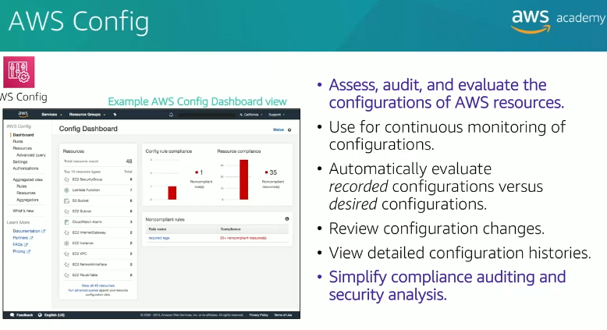

**What is AWS Config?**

AWS Config is a fully managed service that helps you **track, assess, and audit resource configurations in your AWS environment**. It continuously monitors and records the configuration changes of your AWS resources and provides detailed insights into compliance with organizational policies and standards.

**Key Features of AWS Config**

1. **Configuration Recording**:
   * Records the configuration history of supported AWS resources (e.g., EC2, S3, IAM roles).
   * Captures changes in resource attributes over time.
2. **Compliance Assessment**:
   * Automatically evaluates resources against predefined or custom **rules** to check compliance with organizational policies.
3. **Change Management**:
   * Tracks changes to resource configurations, enabling you to understand **who made the change**, **what changed**, and **when it happened**.
4. **Resource Relationships**:
   * Visualizes resource relationships (e.g., an EC2 instance is associated with a specific security group and VPC).
5. **Snapshot and Querying**:
   * Provides a **point-in-time snapshot** of resource configurations.
   * Enables querying of configurations using AWS Config's **Advanced Query** feature.
6. **Integration with Other Services**:
   * Works seamlessly with AWS CloudTrail, AWS Organizations, AWS Security Hub, and AWS Lambda.

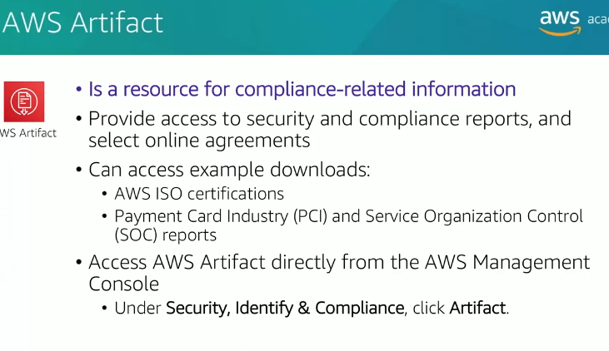

**What is AWS Artifact?**

AWS Artifact is a central repository provided by AWS that offers on-demand access to **compliance-related documents, reports, and agreements**. It is designed to help organizations demonstrate compliance with various regulatory frameworks and industry standards by providing the necessary documentation.

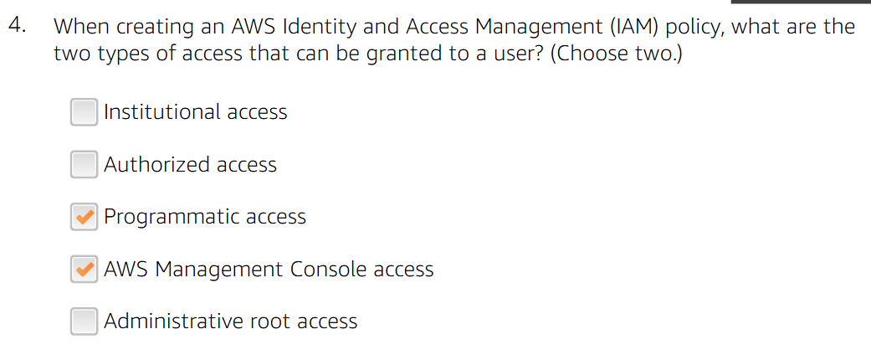

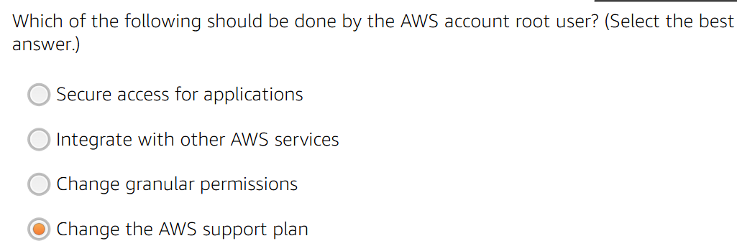

The correct answer is:

✅ **"Change the AWS support plan"**

**Explanation:**

The AWS **root user** should only be used for **highly privileged actions** that cannot be delegated to IAM users. Some tasks that require the root user include:

* Changing the **AWS support plan**
* Closing the AWS account
* Modifying certain account settings
* Accessing **billing information**

**Other options are incorrect because:**  
❌ **Secure access for applications** → Should be managed using IAM roles & policies, not the root user.  
❌ **Integrate with other AWS services** → IAM roles and service-linked roles are used for this.  
❌ **Change granular permissions** → IAM policies and roles should be used instead.

Module 5

NETWORKING AND CONTENT DELIVERY

Topics

· Networking basics

· Amazon VPC

· VPC networking

· VPC security

· Amazon Route 53

. Amazon CloudFront

1.Networking Basics

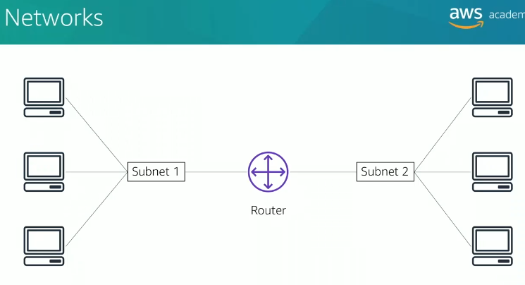

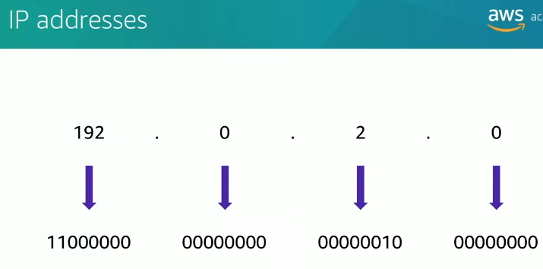

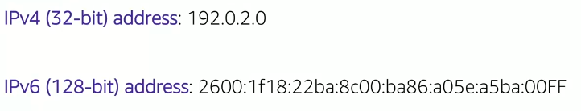

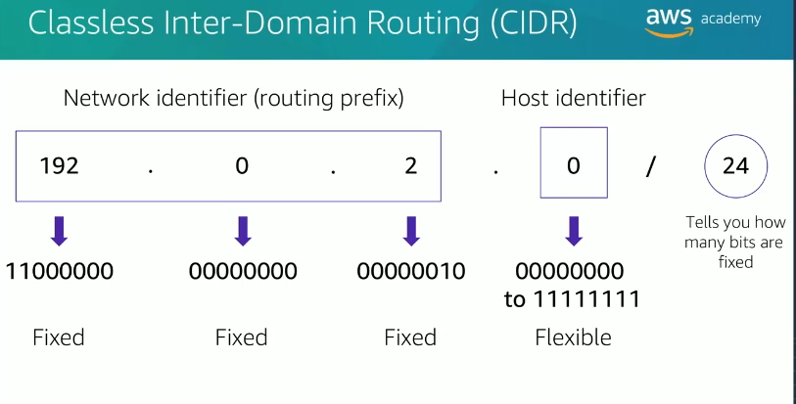

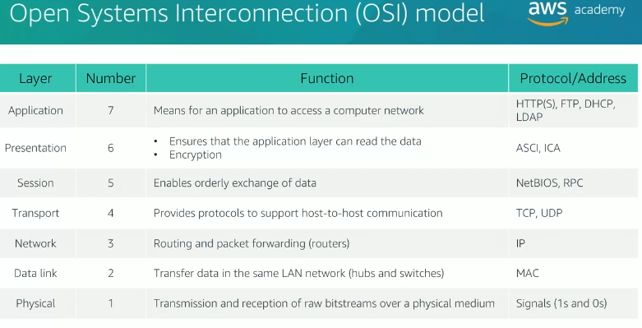

2.VPC

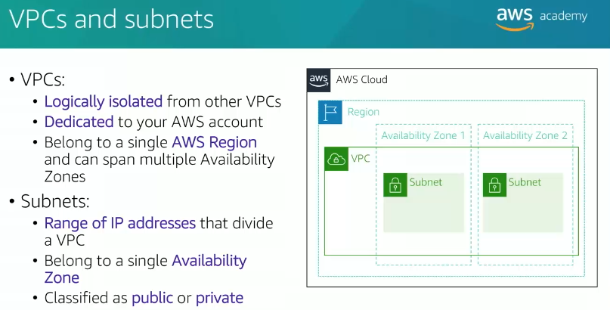

Yes, you can create multiple subnets within a single Availability Zone on AWS; each subnet must reside entirely within one Availability Zone and cannot span across multiple zones.

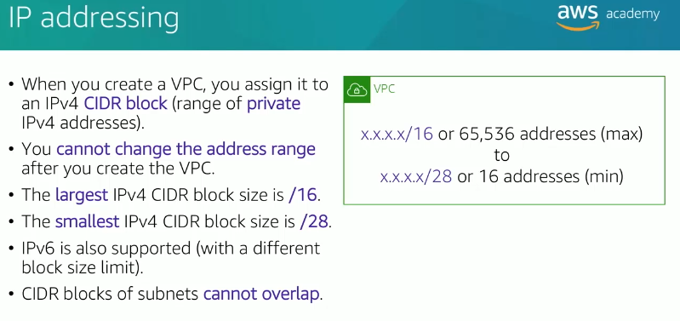

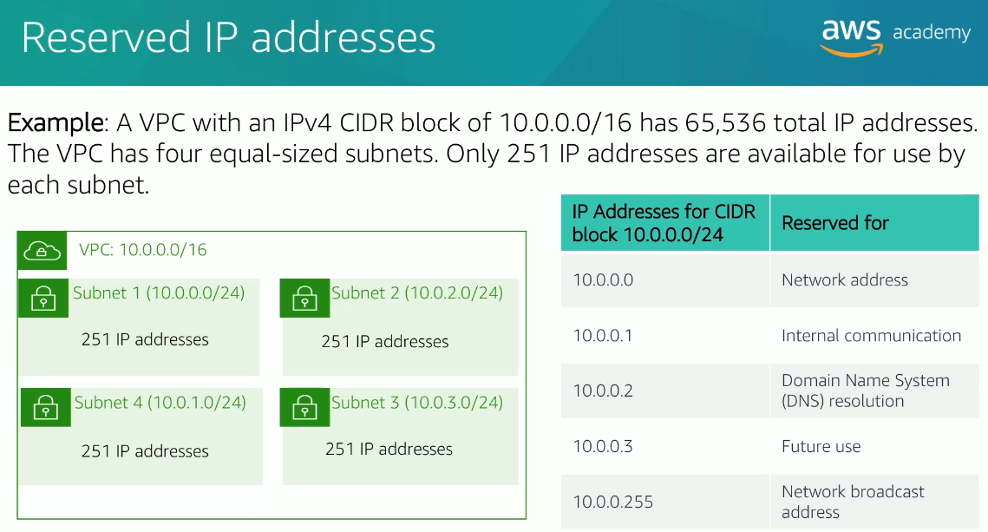

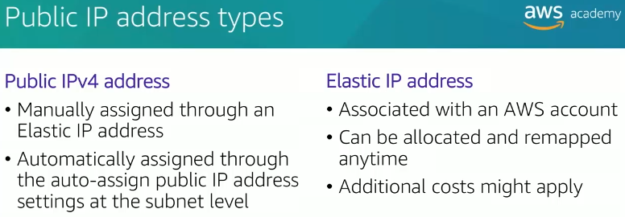

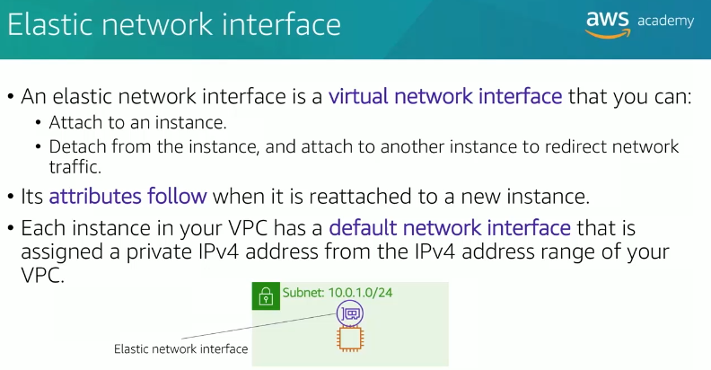

In AWS, a **network interface** (specifically, an **Elastic Network Interface or ENI**) is a virtual network card that you can attach to an EC2 instance in a VPC. It enables the instance to communicate with other resources, such as the internet, other instances, or on-premises networks. Key features include:

* **Multiple IP Addresses**: Can have a primary private IP and additional secondary private/public IPs.
* **Security Groups**: Acts as a virtual firewall for traffic.
* **Attach/Detach**: Can be attached to or detached from instances within the same subnet.

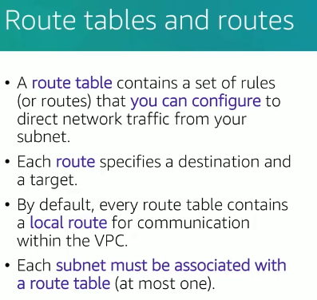

A **NAT Gateway (Network Address Translation Gateway)** is an AWS-managed service that allows resources in a **private subnet** to access the internet or other AWS services while keeping those resources **hidden from the public internet**. It facilitates secure outbound traffic while blocking unsolicited inbound traffic.

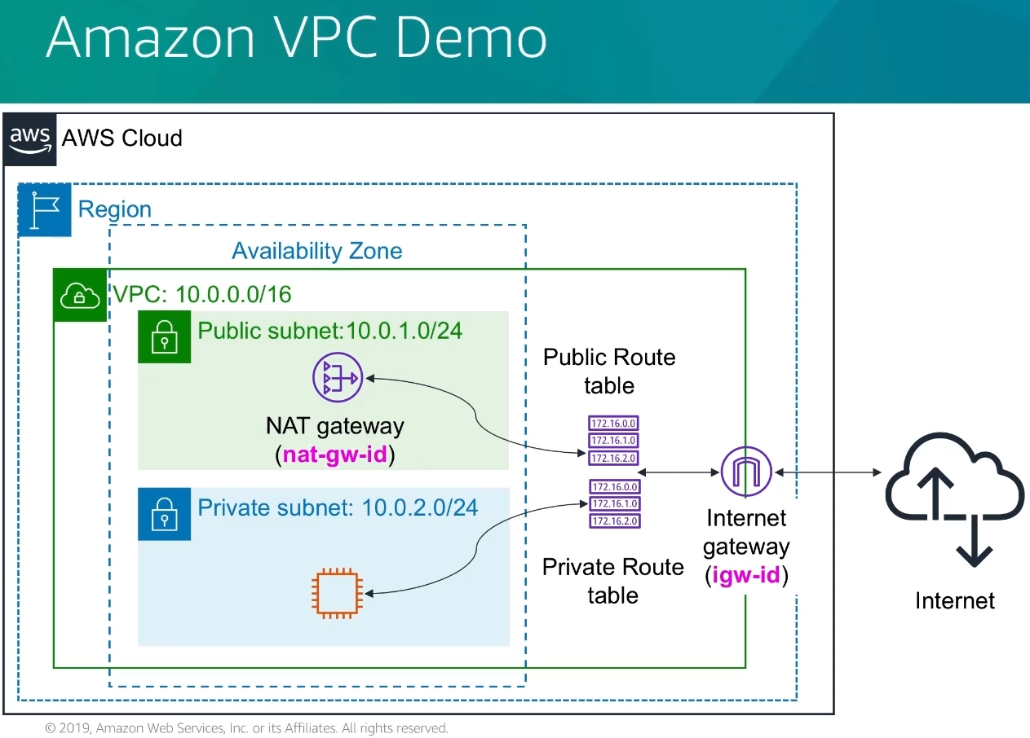

3.VPC NETWORKING

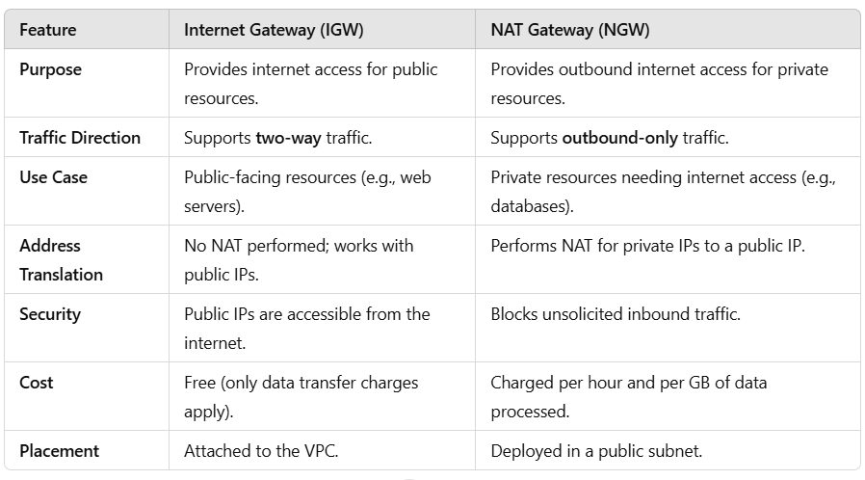

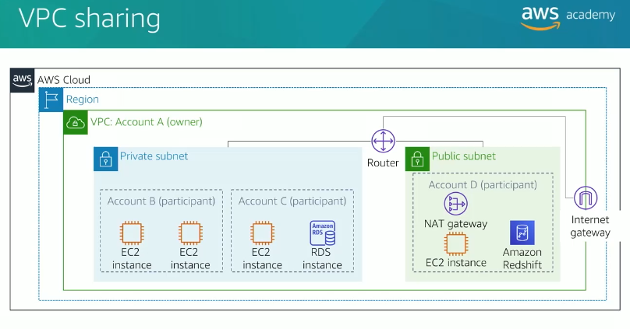

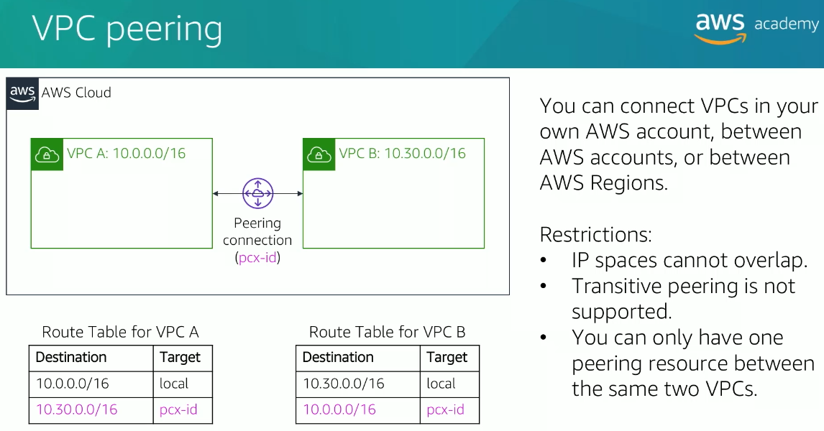

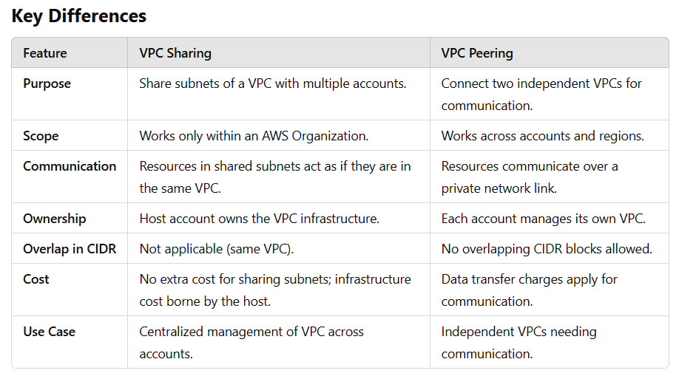

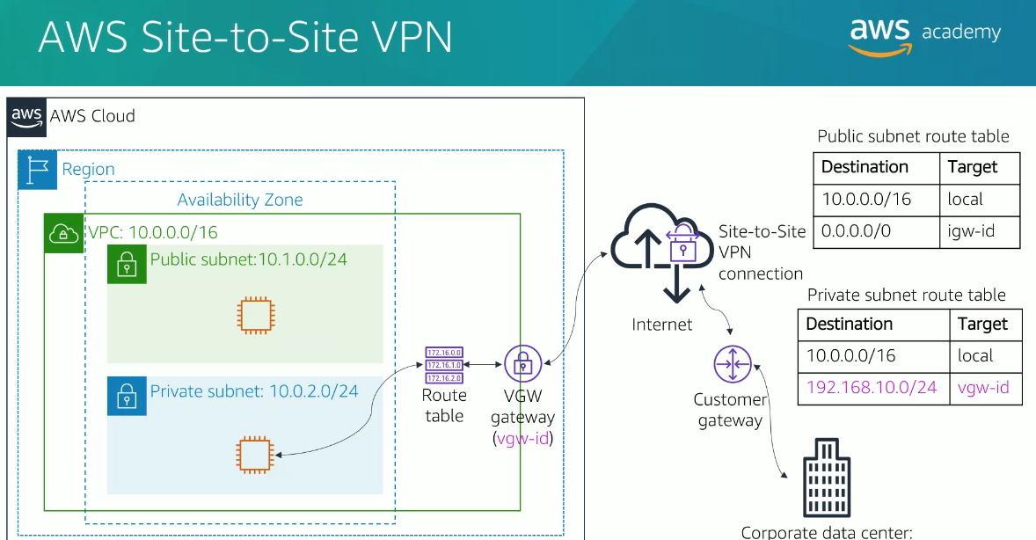

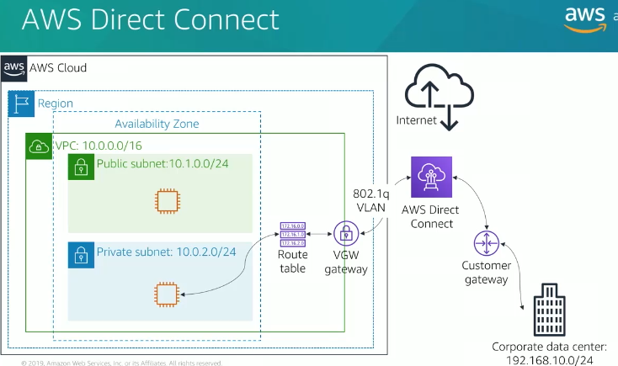

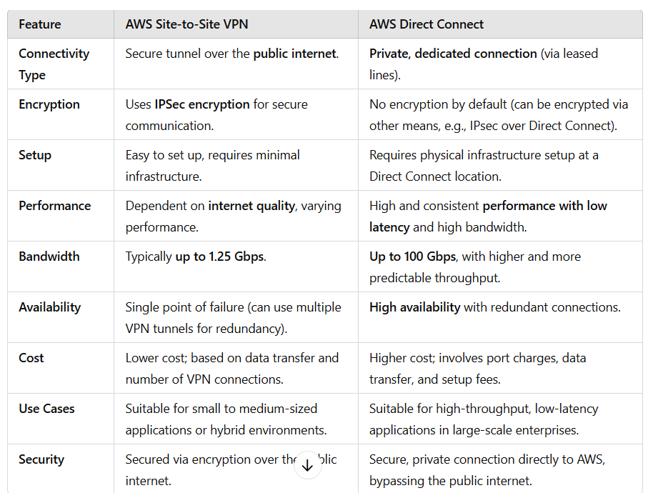

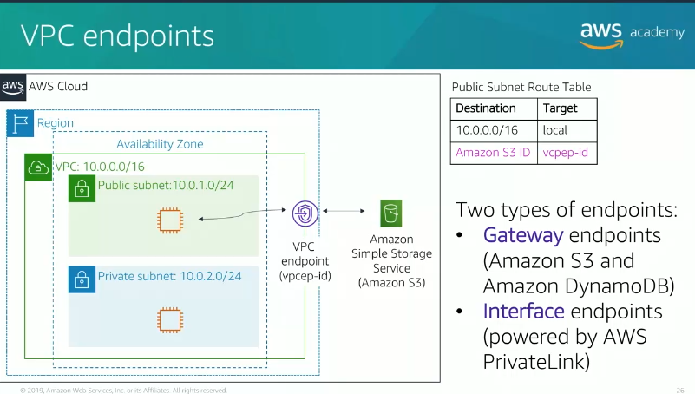In AWS, **VPC endpoints** allow you to privately connect your VPC to supported AWS services without using the public internet. There are **two types of VPC endpoints**:

**1. Interface VPC Endpoint:**

* **What it is**: An Elastic Network Interface (ENI) with a private IP address that serves as an entry point for traffic to a supported AWS service.
* **How it works**: Uses **AWS PrivateLink** to securely connect your VPC to services like Amazon S3, DynamoDB, CloudWatch, and many others.
* **Key Features**:
  + Provides private connectivity to AWS services.
  + Supports security groups for fine-grained access control.
  + Works with most AWS services.
* **Use Case**: Ideal for accessing services that are not natively supported by Gateway Endpoints (e.g., AWS Lambda, SNS, SQS).

**2. Gateway VPC Endpoint:**

* **What it is**: A virtual gateway that you add to your VPC route table to route traffic to supported AWS services.
* **How it works**: Directs traffic to services like **Amazon S3** and **DynamoDB** without using an internet gateway, NAT device, or VPN.
* **Key Features**:
  + No additional cost or performance overhead.
  + Automatically routes traffic within the AWS network.
  + Only supports **Amazon S3** and **DynamoDB**.
* **Use Case**: Ideal for accessing S3 or DynamoDB privately and cost-effectively.

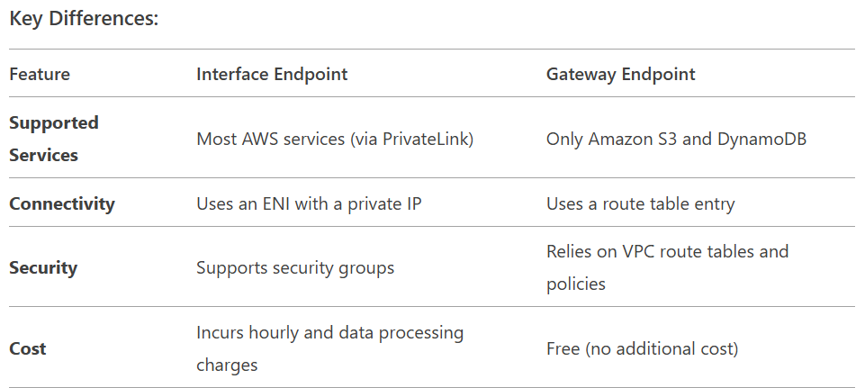

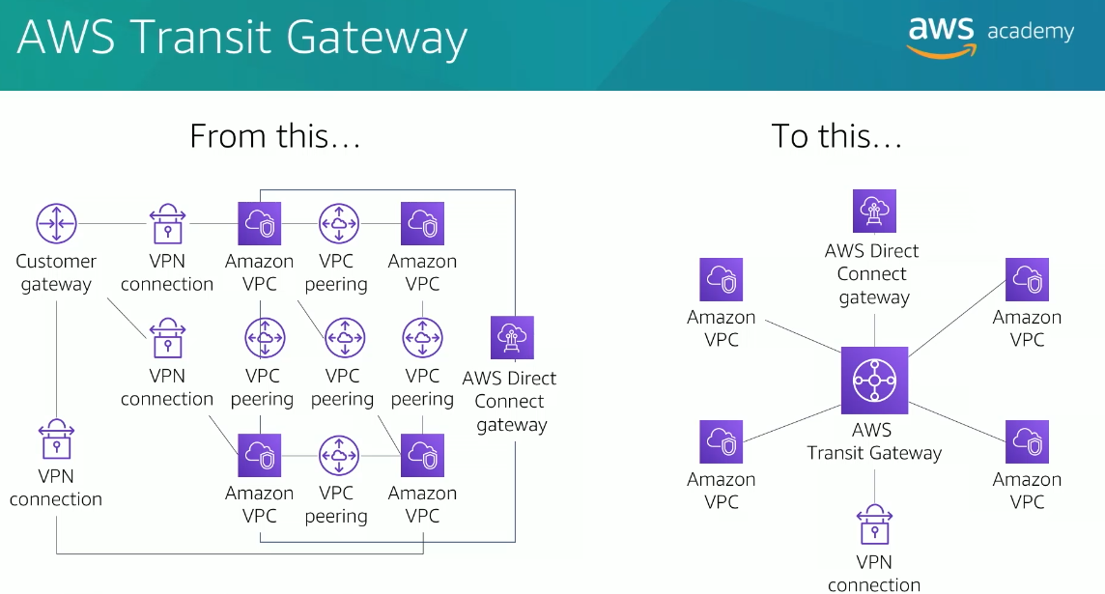

**AWS Transit Gateway** is a highly scalable and fully managed service that enables you to **connect** multiple VPCs (Virtual Private Clouds), **on-premises networks**, and other AWS resources into a **centralized hub** for easier management and better routing control. It simplifies the networking architecture by acting as a hub-and-spoke model for connecting VPCs and other networks, improving security, scalability, and performance.

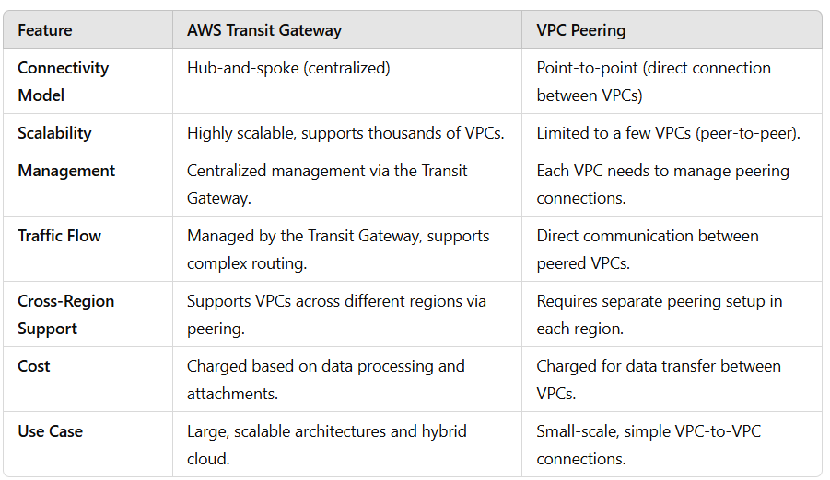

4.VPC SECURITY

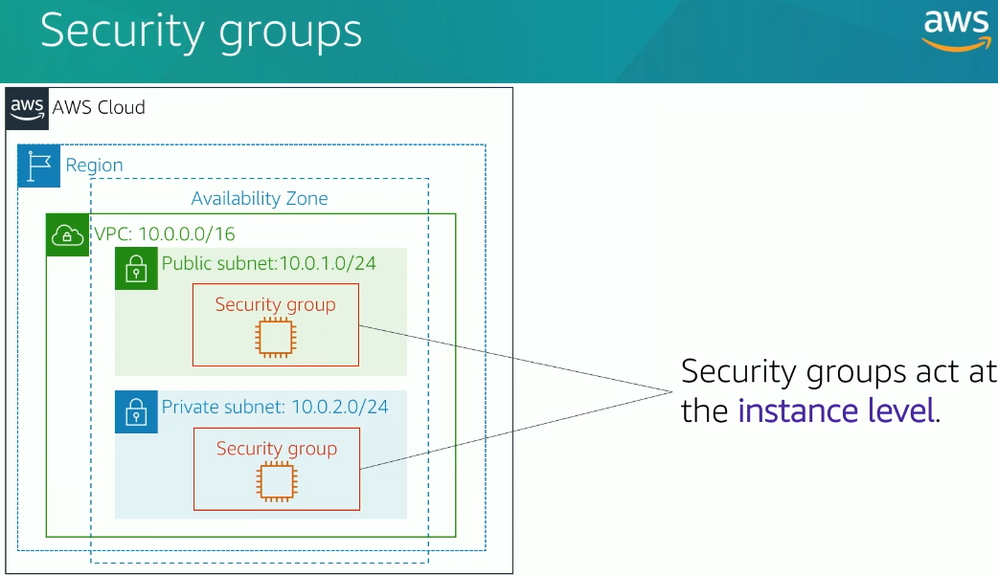

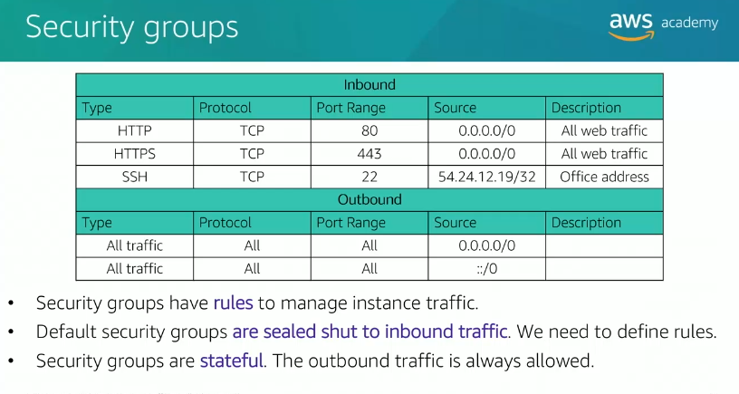

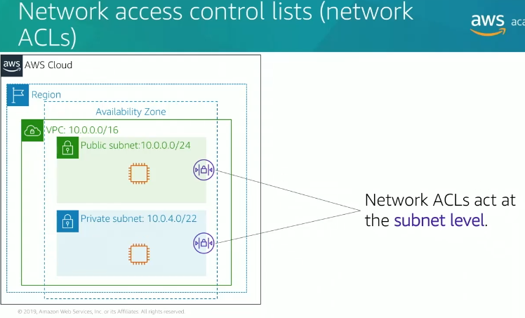

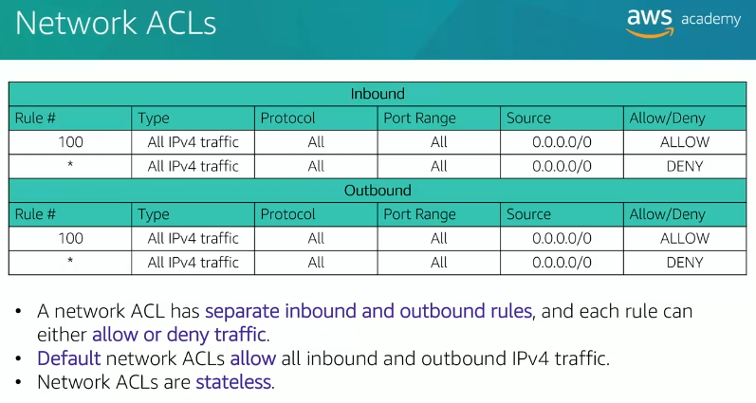

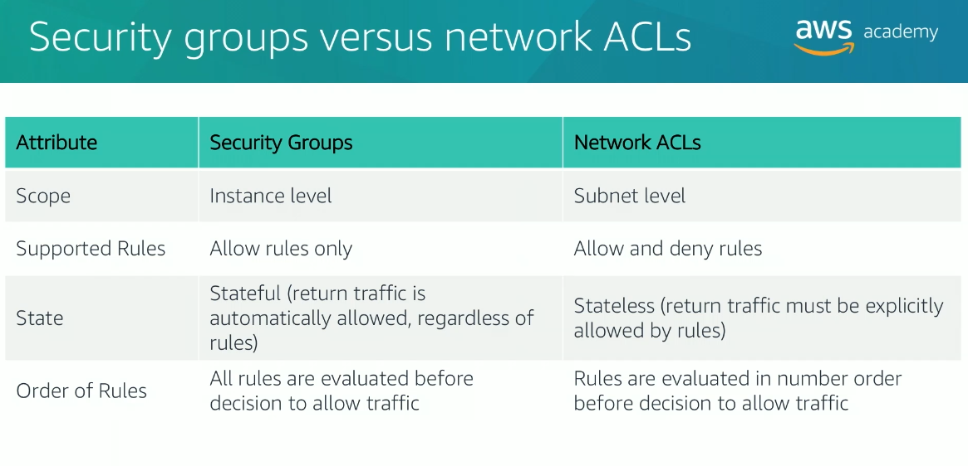

5.ROUTE 53

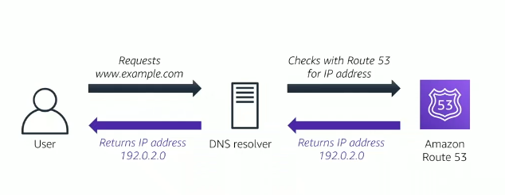

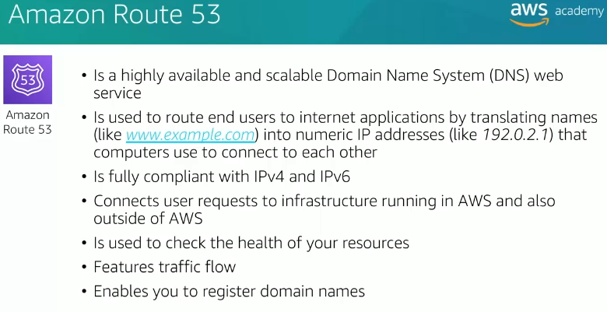

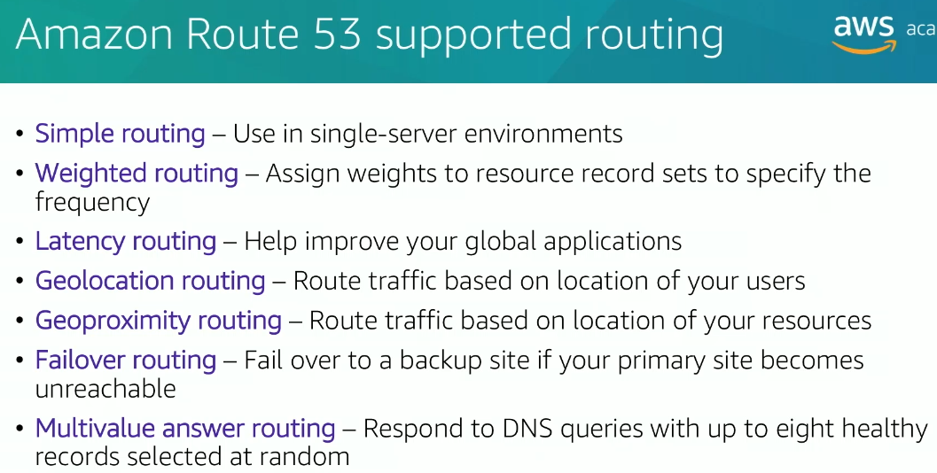

**1. Simple Routing**

* **Description**: Simple routing is used in situations where you only have a single server or resource that you want to route traffic to. This is the default routing policy.
* **Use Case**: Ideal for websites or applications hosted on a single server.
* **Example**: You have a website hosted on an EC2 instance with the domain www.example.com. With simple routing, Route 53 resolves all traffic directed to www.example.com to this single server.

**2. Weighted Routing**

* **Description**: Weighted routing allows you to assign weights to resource record sets to control how much traffic is directed to each resource. The weight can be adjusted to determine the proportion of traffic going to each endpoint.
* **Use Case**: When you have multiple resources (like EC2 instances) and want to distribute traffic between them based on defined weights (for load balancing or testing new resources).
* **Example**: You have two EC2 instances hosting a website, one with weight 70 and the other with weight 30. Route 53 will route approximately 70% of the traffic to the first instance and 30% to the second instance.

**3. Latency Routing**

* **Description**: Latency routing improves global applications by directing user traffic to the AWS region that provides the lowest latency for the user.
* **Use Case**: When you want to optimize response times for users across different geographical locations.
* **Example**: If you have applications deployed in AWS regions such as North Virginia and Singapore, Route 53 will route a user from India to the Singapore region and a user from the U.S. to the North Virginia region to minimize latency.

**4. Geolocation Routing**

* **Description**: Geolocation routing routes traffic based on the geographic location of the users. This is useful when you want to direct users from different regions to specific resources.
* **Use Case**: You can route traffic to region-specific content, such as a local version of a website.
* **Example**: If a user from Europe visits your website, Route 53 can route them to a server located in Europe, while users from the U.S. might be routed to a U.S.-based server.

**5. Geoproximity Routing**

* **Description**: Geoproximity routing routes traffic based on the location of both the user and the resources. This is similar to geolocation routing but adds the factor of resource proximity. You can also specify bias to prefer closer resources or avoid distant ones.
* **Use Case**: Ideal when you want to route traffic not just based on user location but also considering the resources' proximity to those users.
* **Example**: If you have two data centers, one in Europe and one in Asia, Route 53 can route traffic to the closest available resource while considering both user and resource proximity.

**6. Failover Routing**

* **Description**: Failover routing ensures high availability by automatically routing traffic to a backup site if the primary site becomes unreachable. You need to define both a primary and a secondary (failover) resource.
* **Use Case**: When you want to ensure that if your primary resource fails, the traffic is rerouted to a secondary, backup resource.
* **Example**: You have your main website running on an EC2 instance. If that EC2 instance becomes unhealthy or unreachable, Route 53 can fail over to a backup website hosted in another region.

**7. Multivalue Answer Routing**

* **Description**: Multivalue answer routing returns multiple IP addresses (up to eight) in response to a DNS query, helping with load balancing. This method randomly selects healthy records and returns them in response to DNS queries.
* **Use Case**: Useful when you want to balance traffic across multiple healthy resources and improve fault tolerance.
* **Example**: If you have several web servers and want to distribute the traffic evenly across them, Route 53 will return multiple IP addresses (up to 8) for your domain, and the DNS resolver will pick one at random for each query.

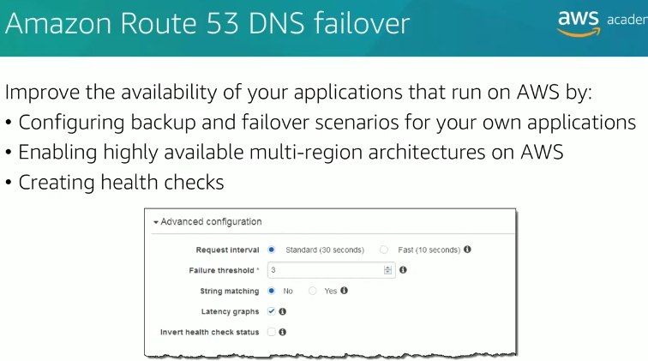

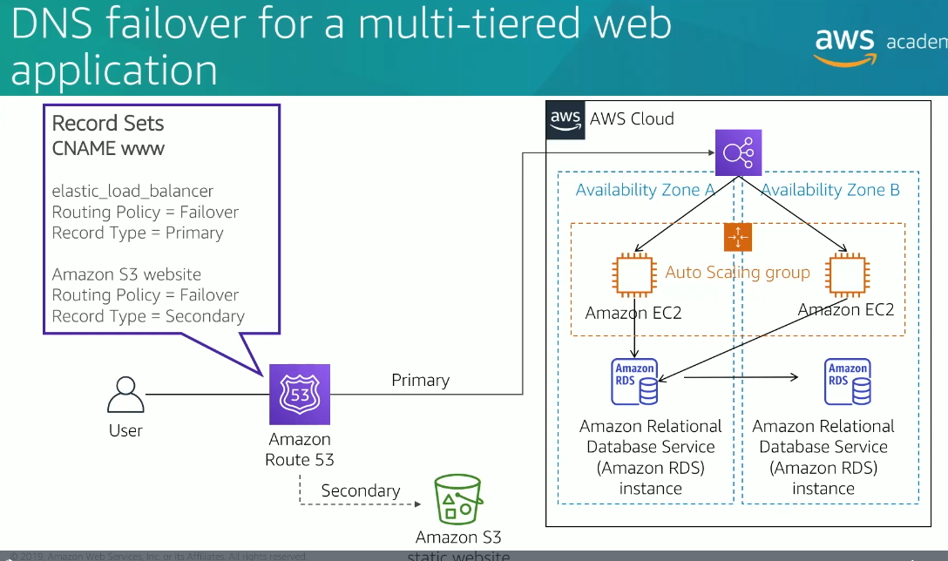

6.CloudFront

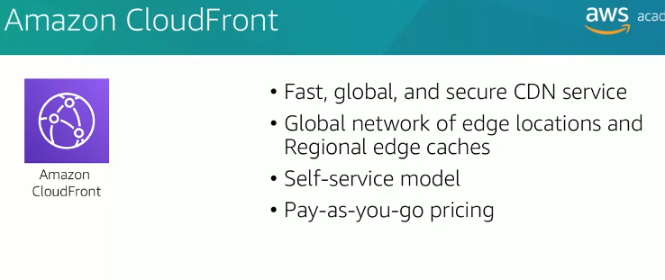

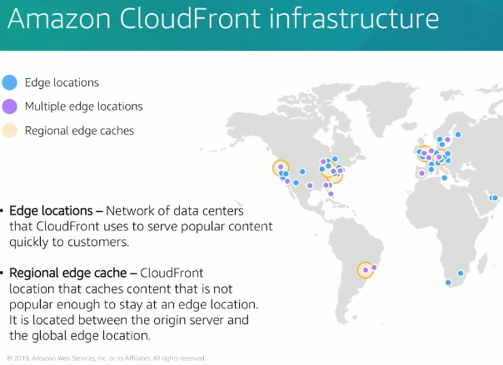

Amazon CloudFront is a content delivery network (CDN) service provided by AWS that speeds up the distribution of your content, such as web pages, images, videos, and other static or dynamic files, to users across the globe. It helps deliver content with low latency and high transfer speeds by caching copies of your content at edge locations (data centers) around the world.

Key features of CloudFront include:

1. **Global Distribution**: CloudFront has a network of edge locations across various regions, ensuring content is served from the nearest location to the user, reducing latency.
2. **Scalability**: It automatically scales to handle growing traffic without requiring manual intervention.
3. **Security**: Integrated with AWS services like AWS Shield (DDoS protection) and AWS Web Application Firewall (WAF), CloudFront helps secure content delivery. You can also use HTTPS to encrypt data in transit.
4. **Cache Control**: CloudFront allows you to control caching behavior to optimize performance. You can define cache expiration, specify cache policies, and even use Lambda@Edge to run functions at edge locations.
5. **Integration**: It integrates with other AWS services, such as S3 (for storing static content), EC2 (for dynamic content), and Elastic Load Balancing (for scaling applications).

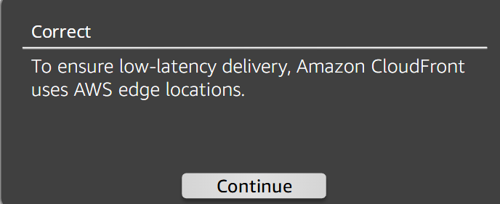

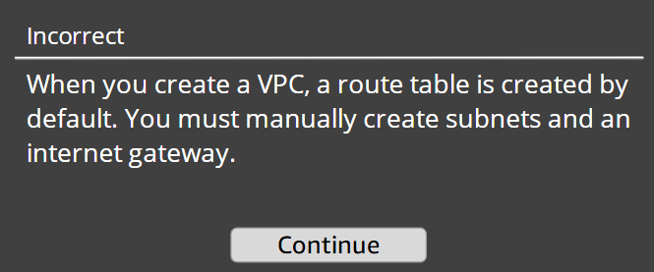

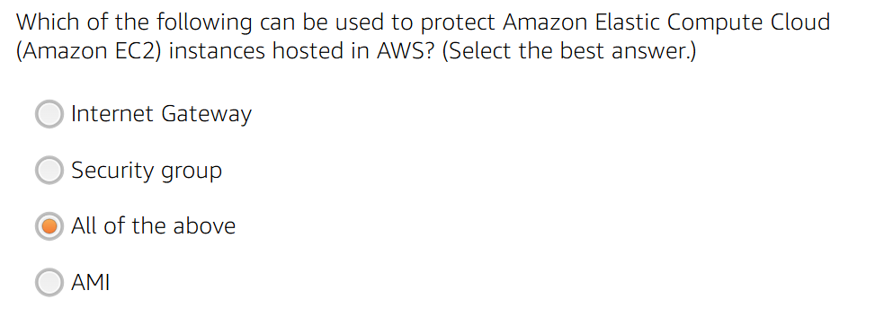

Incorrect:

Ans: B